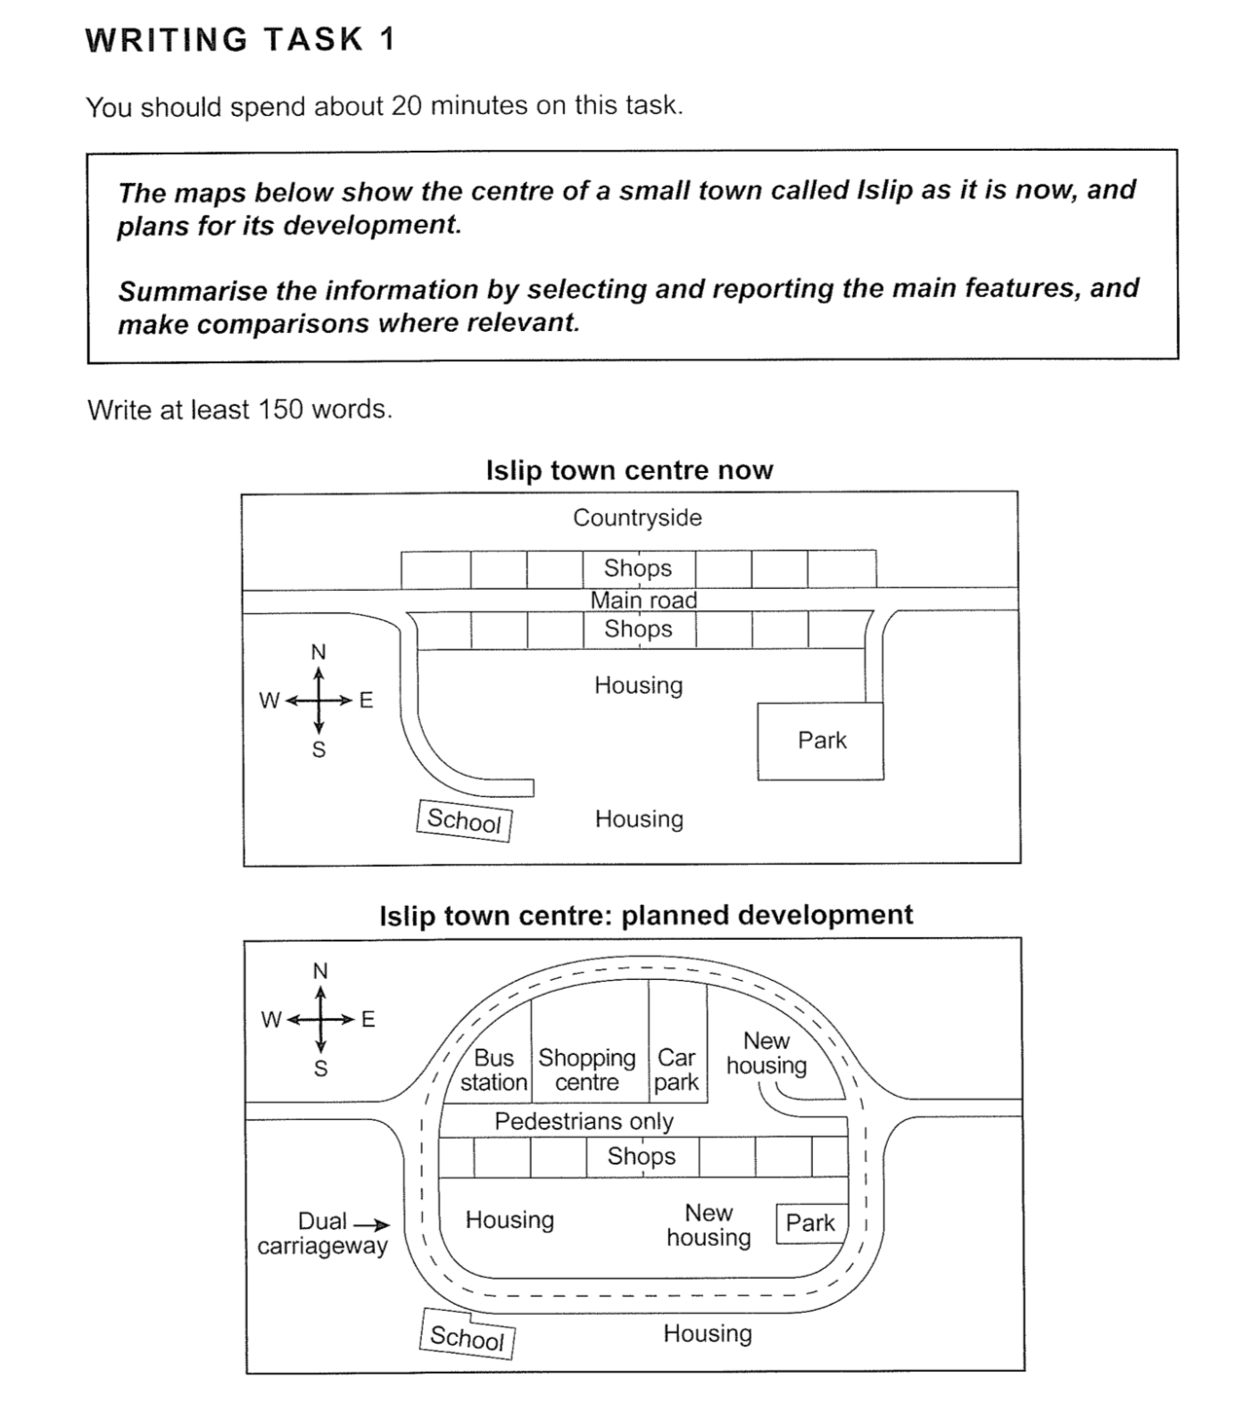

The pictures illustrate how the layout of a small town named Islip will change in the future.

Overall, the town will become more residential with more facilities and improved transportation.

Currently, the layout of the town is relatively simple: the northern part is the countryside, next to which are located two rows of shops separated by a main road crossing the town centre. Two housing areas are situated in the middle and the south of the town respectively. A school is built in the south-west, whereas there is a park in the south-east. Both are connected by paths to the main road.

In future, the town will go through tremendous changes. A new dual carriageway will be introduced to surround the town centre, excluding the school and one original housing complex. Within the roadway, the main road will be pedestrianized. On its northern side, the countryside and the shops will be converted to a bus station, a shopping centre, a car park and a new housing area, while, on the opposite side, the shops will remain unchanged. Another residential zone will be constructed to the west of the park which will be significantly smaller.
(~196 words)

